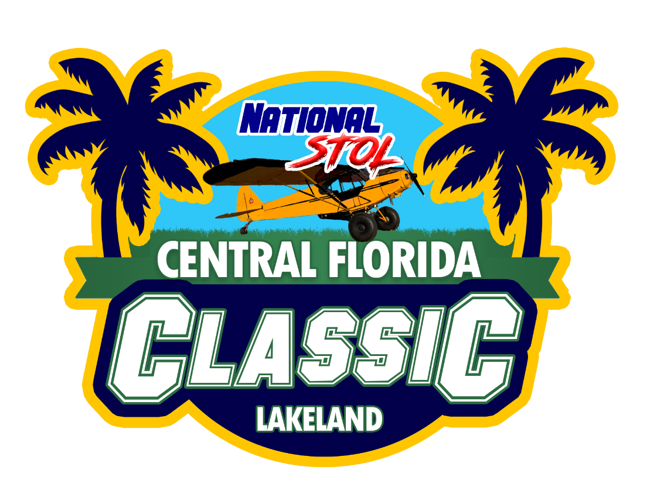

2020 NATIONAL STOL RULES
All pilots should have a copy of these rules in their airplane prior to the start of the competition. Know the rules. Safety is our number one priority.

If you are in doubt of the rules, ASK QUESTIONS. Email info@nationalstol.com or ask at the event!

Pilot's Information - Safety & Registration Rules

- Aviate - keep your eyes peeled for traffic. Fly safe patterns. Go around if needed.
- Communicate – Use the following frequencies, keep communications clear and to the point.
- Competition frequency TBD
- Manage your fuel! - Maintain minimum 30-minute reserve per FAA.
- No steep climbs, hot-dogging, low passes, or abrupt maneuvers on take-off or in the pattern.
- Pattern Altitude 500 ft AGL minimum.
- Fly rectangular traffic patterns. Altitude TBD.
- No hand propping of aircraft without someone at the controls and wheels chocked, or the tail tied down.
- Pilot license and current medical certificate (if required) must be in your possession.
- FAA required paperwork must be in your aircraft (AROW).
- Air Boss and the Competition Director (CD) have authority to disqualify any participant deemed unsafe.
- All persons flying in the competition events, must attend a pre-event safety briefing for each event that you are participating in. Attendance is required to participate. There will be a roster that you will need to sign.

General Short Field Takeoff & Landing (STOL) Rules:
1. Each pilot/aircraft combination will be allowed a set number of takeoffs and landings (or cycles) in the STOL event.
2. Score will be based on the best takeoff and landing cycle. (i.e. either the best set of the 1st takeoff and landing, or the second takeoff and landing.)
3. Only one combination of pilot/aircraft will be allowed. However, individual pilots will be allowed a maximum of two runs (for those wishing to fly two separate aircraft) and Individual aircraft will be allowed a maximum of two runs (for those wishing to have their aircraft flown two separate times).
4. Heat and competitor assignments (example: “Heat B – Number 3”) will be posted at the Safety Briefing.
5. Pilots must call ground control in time to taxi for staging for their heat. Failure to call on time is grounds for a DQ. Call ground using your heat and number. Example "Classic parking, Bravo 3 is ready to taxi for staging, located in competition parking.”
6. On the ground pilots are responsible to observe sequence and be ready to follow previous group (heat).

Short Field Take-Off Rules:
1. Taxi into position as directed by line judge, with main gear stopped on reference line.
2. Begin take-off roll after the airboss instructs, “Bravo 1 – go”. Once the aircraft starts their departure roll, the next aircraft should already have started their taxi towards the starting line.
3. Take-off distance will be measured to where the furthest main wheel leaves the ground for the last time. All measurements will be taken at the main gear axle.

Short Field Landing Rules:
1. Main gear must land on or beyond the reference line.
2. Main gear touchdown prior to reference line is disqualifying.
3. Tailwheel touchdown prior to reference line is NOT disqualifying.
4. “Go Arounds” are not an uncommon real-world safety decision if conditions deteriorate on short approach and you are too close to the edge of the safe flight envelope. For the STOL competition, a “Go Around” is encouraged and expected if it is necessary. If no contact of any landing gear has been made, the pilot can circle around for a second landing attempt and still be scored. This rule is not to be abused for practice approaches. The chief line judge has the sole discretion to determine if the “Go Around” policy was abused and DQ that cycle.
5. Aircraft must come to a full stop, straight ahead, and remain stopped until judges have had a chance to measure and wave you clear of the runway.
6. Landing distance will be measured from the reference line to the main gear axle.
7. Return to staging area for second attempt. Be aware to not turn in front of crowd due to prop wash.
8. Park after second attempt.

Registration and Safety Briefing:
- Registration will be online! There are limited opportunities to register at the event.
- Registration for STOL closes at: TBD
- Mandatory Safety briefing for STOL Competition is: TBD

Pilot's Information - STOL Classes

Rules for Classing Aircraft:
- Classes are defined below by model and certification type. If an aircraft model is not indicated, then gross weight will be used, as defined by the aircraft's airworthiness certificate.
- There must be at least two aircraft in a class for the class to compete.
- Gliders, unmanned aerial vehicles, rotorcraft, powered parachutes, weight-shift, and lighter-than-air craft may not compete.
- FLYING IN THE WRONG CLASS WILL BE AN AUTOMATIC DISQUALIFICATION
- The Competition Director will make all class determinations, which are final.

Pilot's Information - STOL Events

General STOL Rules:

- Each pilot/aircraft combination will be allowed a set number takeoffs and landings (or cycles) in the STOL event.
- Score will be based on the best takeoff and landing cycle of each event. (i.e. either the best set of the 1st takeoff and landing, or 2nd takeoff and landing.)
- Only one combination of pilot/aircraft will be allowed. However, pilots may fly two different aircraft and individual aircraft may be flown by two different pilots (for those wishing to have their aircraft flown two separate times).
- Certificated and Experimental Aircraft of the same Class will fly together, but be scored with their type (certificated or experimental).
- PILOTS MUST BE TUNED TO 123.40 WHEN ON DECK. Failure is grounds for disqualification.
- Pilots are responsible to observe sequence and be ready to follow previous group.
- Sequence will be announced at the Safety Briefing.

Replay Information
Camera Replays may be used to challenge distance measurements and line judge calls. Further information is forthcoming.

General Information
Tie downs and chocks are your responsibility. You must tiedown your aircraft.
Plane handlers will be safety vested volunteers.
Sufficient porta potties will be available.
We want to emphasize that all flying will be FAR compliant.
If you do not make the briefing you will not fly. It will be up to the classes to police themselves, attend briefing, start-up, perform a sufficient warm up, and taxi down to the marshaling area in takeoff order. All competition paperwork should be turned in by Friday evening.
You cannot leave your aircraft unattended unless it’s tied down.
BRING YOUR OWN TIEDOWNS.

